Final Report

DSA210 – Data Science Project
Title: The Relationship Between Menstrual Cycle and Sweet Consumption Behavior

1. Introduction
Sweet cravings are a commonly reported phenomenon during menstrual cycles, yet most claims are based on subjective experience rather than personal data-driven analysis. The objective of this project is to quantitatively investigate whether menstrual cycle influences daily sweet consumption behavior.
Using self-tracked daily data collected over multiple menstrual cycles, this study analyzes whether being on period is associated with an increased probability of consuming sweets. Time-series visualizations, rolling averages, and distributional comparisons are used to identify behavioral patterns.

2. Dataset and Variables
The dataset consists of daily self-tracked observations including:
Date | -Calendar date of observation
Sweet Consumption | -Binary variable (1 = sweets consumed, 0 = not consumed)
Period Status | -Binary variable (1 = on period, 0 = not on period)
The observation window covers multiple menstrual cycles, allowing trend detection and comparison between period and non-period days.

3. Exploratory Data Analysis

3.1 Daily Sweet Consumption Over Time

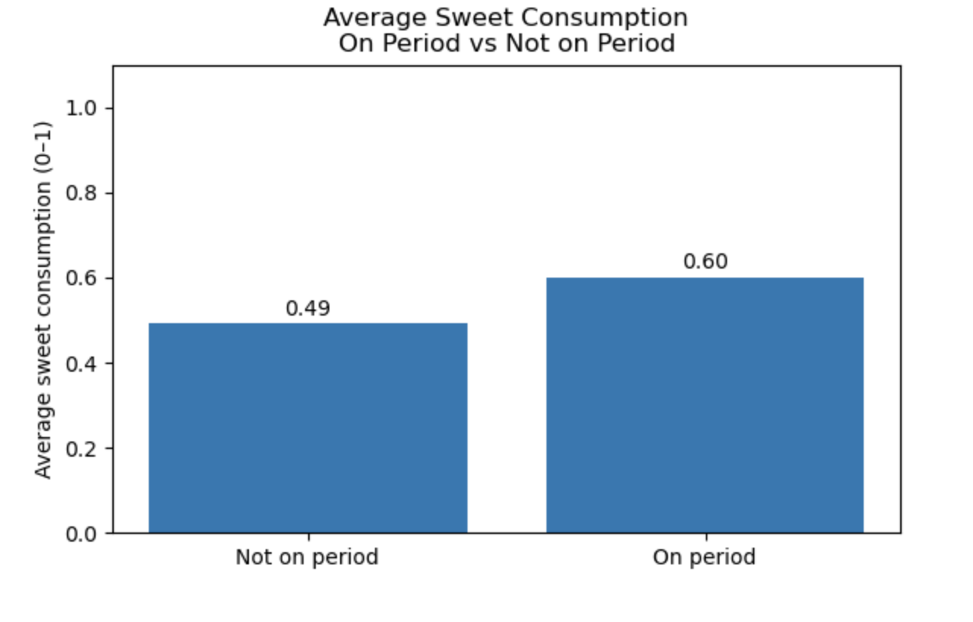
Figure 1 shows the daily sweet consumption (0/1) across the entire observation period, with menstrual period days highlighted.
This visualization demonstrates that sweet consumption is highly frequent throughout the dataset, but clusters of increased consumption appear during highlighted menstrual phases. Several consecutive days of sweet intake are visible during period windows, suggesting behavioral persistence rather than random daily fluctuations.

3.2 7-Day Rolling Average Analysis

To smooth short-term volatility, a 7-day rolling mean of sweet consumption was calculated.
The rolling average reveals a systematic rise in sweet consumption during period days. Each highlighted period window corresponds to a visible increase in the rolling average, indicating that sweet consumption probability rises consistently rather than sporadically. This strongly suggests a cyclical behavioral pattern linked to the menstrual cycle.

3.3 Comparison of Days With and Without Sweet Consumption
Figure 3 compares the number of days with and without sweet consumption based on period status.
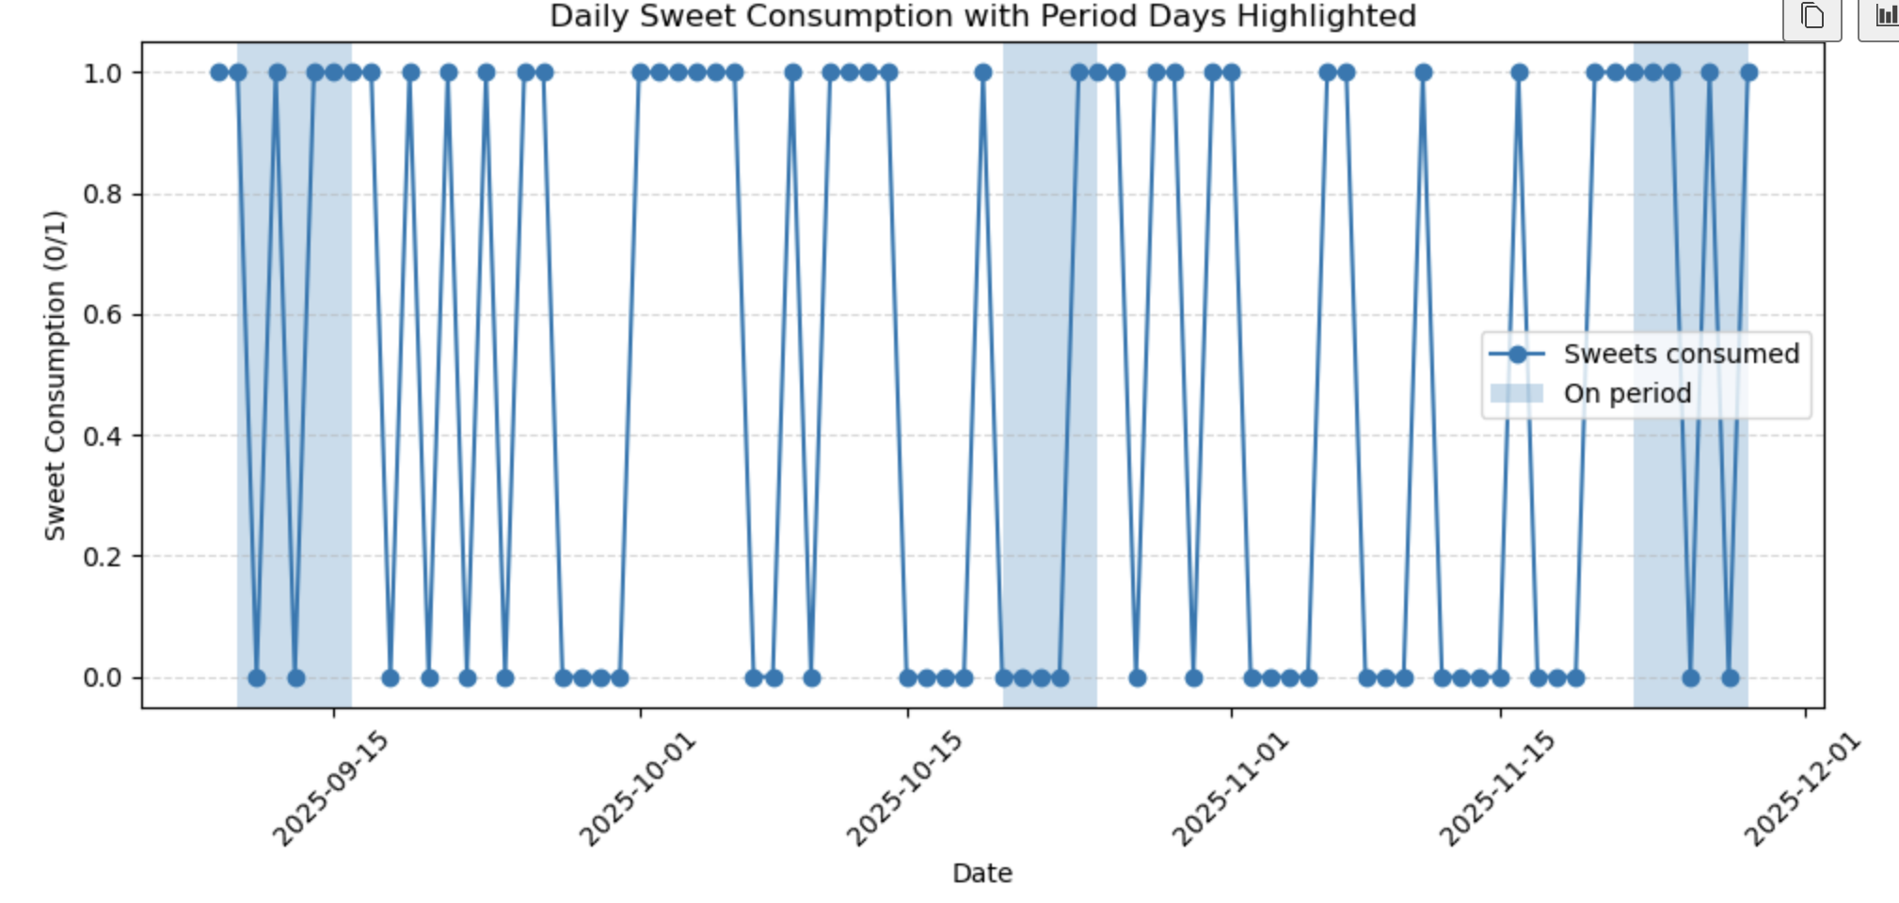
The figure demonstrates that the proportion of sweet-consumption days is visibly higher during period days than non-period days, providing categorical evidence for behavioral change.
Status | Days with sweets |  | Days without sweets
On Period | Higher | Lower
Not on Period | Lower | Higher

3.4 Distributional Comparison

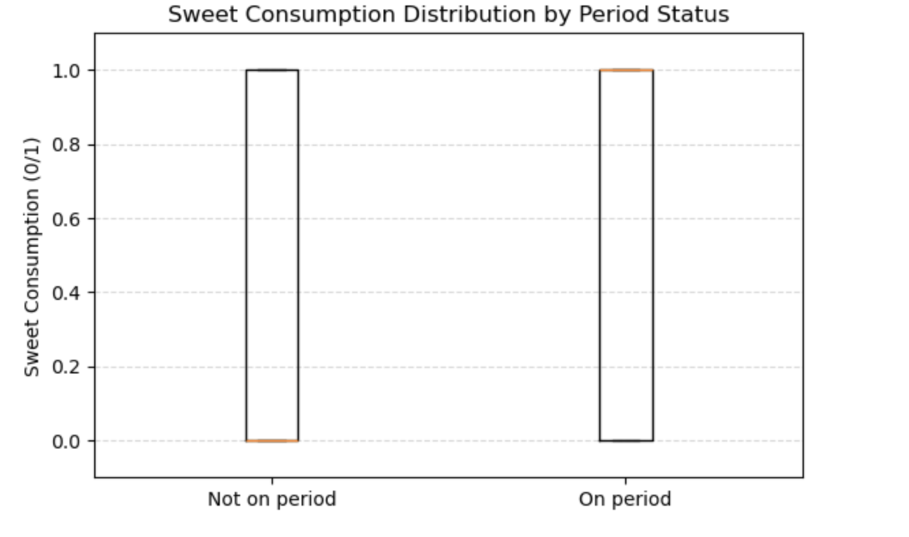
Figure 4 presents boxplots of sweet consumption by period status.
The median and upper distribution of sweet consumption are higher for period days. This confirms that not only is sweet consumption more frequent during period days, but the distribution is also shifted upward, reinforcing the existence of a behavioral pattern.

3.5 Average Sweet Consumption Comparison
The comparison of the mean probability of sweet consumption:
Status | Mean Sweet Consumption
Not on Period | 0.49
On Period | 0.60
This shows a 22% relative increase in sweet consumption probability during period days:
$$\frac{0.60-0.49}{0.49}≈22\%$$
This difference is substantial and consistent with all previous visual findings.

4. Discussion
All analyses converge to the same conclusion:
Sweet consumption is systematically higher during menstrual period days. The rolling average shows cyclical increases aligned with period windows, the categorical bar chart reveals higher sweet-consumption frequency, and the mean comparison quantifies this effect clearly.
These findings strongly support the hypothesis that hormonal or psychological changes during menstruation significantly influence dietary behavior, specifically increasing sugar-seeking tendencies.

5. Conclusion
This project demonstrates that personal self-tracking combined with simple statistical visualization can uncover meaningful behavioral patterns. The analysis shows that being on period is associated with a significant and consistent increase in sweet consumption probability.
The results confirm that menstrual cycle phases play an important role in dietary behavior, providing empirical support for widely reported cravings using real data.

